Entergy Vermont Yankee
320 Governor Hunt Rd.
Vernon, VT 05354

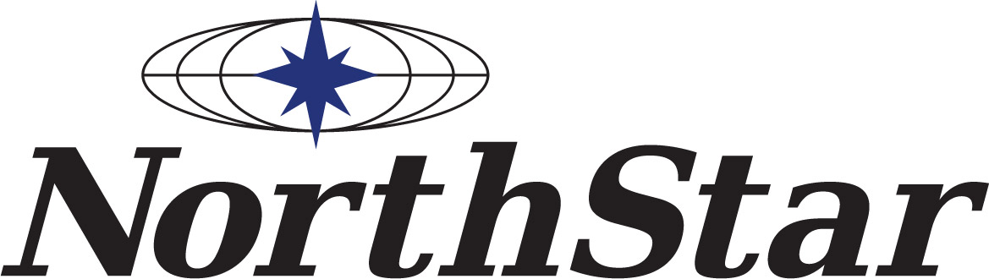
News
Release
Date: January 11, 2019
For Release: Immediately

Contact:
Anthony Iarrapino David Borde Solange De Santis NorthStar Entergy Investor Relations Entergy Communications
Cell (802) 522-2802 Office (504) 576-5668 Cell (917) 379-2260
anthony@ilovt.net dborde@entergy.com sdesa92@entergy.com

Entergy Completes Sale of Vermont Yankee to NorthStar

Vernon, VT – – Entergy Corporation (NYSE:ETR) today completed the sale of Entergy Nuclear Vermont Yankee to subsidiaries of NorthStar Group Services, which will decommission the Vermont Yankee Nuclear Power Station site.
The sale completion is a major step toward the safe, timely, and efficient decommissioning of Vermont Yankee, and is a positive outcome for the Town of Vernon, Windham County, the State of Vermont and other stakeholders. In addition, Entergy is continuing to fulfill its corporate strategy of exiting the merchant nuclear power business. The sale is a first-of-its-kind in the nuclear power industry – a permanent ownership and license transfer to a company that is slated to perform timely and efficient decommissioning and site restoration.
The NorthStar decommissioning team includes Orano USA (reactor vessel segmentation and used fuel management support), Waste Control Specialists (waste management, packaging, transport and disposal) and Burns & McDonnell (engineering and regulatory support).
Entergy and NorthStar announced the sale agreement in November, 2016. The Vermont Public Utility Commission on Dec. 6, 2018 issued an order approving the sale of ENVY and an amended Certificate of Public Good that authorizes NorthStar to own, possess the licenses for, and decommission Vermont Yankee. The U.S. Nuclear Regulatory Commission on Oct. 11, 2018 approved the transfer of Vermont Yankee’s operating licenses to NorthStar.
The transaction closed on terms consistent with the companies’ previously disclosed financial commitments and assurances, and no contribution to the nuclear decommissioning trust was required. For Entergy, the transaction will result in a pre-tax book charge to earnings in an amount that the company expects to be consistent with estimates previously disclosed. The estimated charge will be recorded in fourth quarter 2018 and will be considered a special item and excluded from operational results.
About Vermont Yankee, Entergy and NorthStar
Vermont Yankee Nuclear Power Station, a single unit boiling water reactor located in Vernon, Vermont, began commercial operation in 1972. Entergy acquired the plant from Vermont Yankee Nuclear Power Corporation in 2002. The plant permanently ceased operations on Dec. 29, 2014.
Entergy Corporation (NYSE: ETR) is an integrated energy company engaged primarily in electric power production and retail distribution operations. Entergy owns and operates power plants with approximately 30,000 megawatts of electric generating capacity, including nearly 9,000 megawatts of nuclear power. Entergy delivers electricity to 2.9 million utility customers in Arkansas, Louisiana, Mississippi and Texas. Entergy has annual revenues of approximately $11 billion and more than 13,000 employees. More information is available at www.entergy.com and www.vydecommissioning.com.
NorthStar Group Services, based in New York, is the country’s most comprehensive facility and environmental solutions company, with more than $600 million in annual sales and licenses in all 50 states. NorthStar owns and maintains a large, nationwide inventory of specialized dismantling equipment and employs more than 3,000 people. More information is available at www.northstar.com.
-30-

